|  |  |
| --- | --- |
| Gen AI Learning  **Complete Generative AI Learning – New Year Challenge** | Written By: Aloy |

**Day -3**

**Agenda:**

* **Creating Python Environment Creation Automatically**

To perform the new environment creation and automatic requirements.in file creation, place the below file in C:\Users\Admin\Documents\WindowsPowerShell path.

**Steps:**

1. Place the PowerShell script in the path mentioned above.
2. Open the PowerShell terminal in the folder path where you want to create the solution and Python environment.

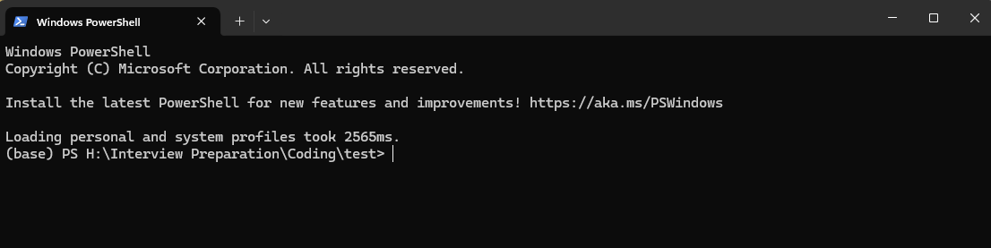

1. Type **newvenv** in PowerShell to create a new environment. If you face any issues while making the environment, type **cf** to create a folder before running the **newvenv** command.

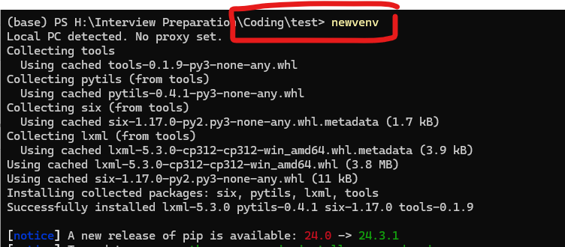

1. This will create a new environment with requirements.in file. Fill the requirements.in file with required packages for installation like below, and run **pip-compile** for creating necessary requirements.txt file automatically handling the dependency of version required.

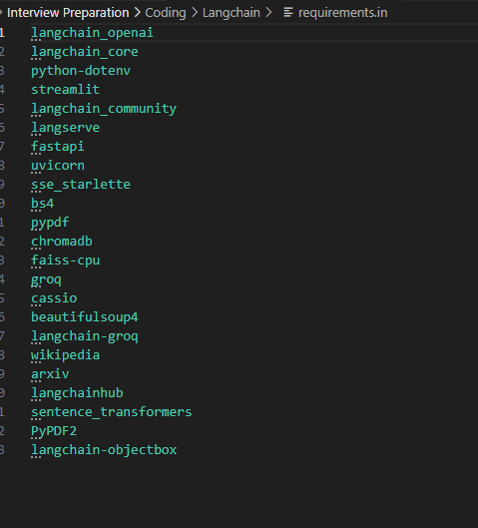

1. Finally, run **pip-sync** to install the packages. Once this step is done you are good to go for your coding.

**Happy Coding ….**

